13016209: Object-oriented Concepts and Programming
Second Semester, 2017

Project assignment - Proposal

- Project developer
Student ID | Name
59090038 | Warakorn Jetlohasiri

- Project title
SNOOP PHOTO

- Project description and requirements
Project Description:
The Project “SNOOP PHOTO” is the program that allows users to swop the
face at real time with an image file that contains an individual’s face extracted from user
input. The purpose of this project is to allow users to understand the concept of Object
Oriented-Programming using “Image Processing (using Open CV)” involving to facial
characteristics of any individuals and allow users to obtain images of their faces being
replaced with an individual that users may have selected. This project has been inspired
from a unique feature of facial swapping from a famous application called “SnapChat.”
The project consists of 3 main features that users may use to play with their
own video camera which include “Face Swapping”,“Adding mask” ,and “ColorMapping”
The face swop section mainly uses the advantages from library called DLib that contain
instant algorithm used to detect each particular points on a face. Several image processing
functions have been used such as, affine transformation, face detection, color correctness
and etc. However, the features “Adding mask”, and “Color-Mapping” only apply
functions from Opencv 3.0 library such as, facial detection, bitwise operation, alpha
blending, threshold operation, and color-mapping operation.
Project requirements:
The Face Swappers project require 2 libraries include OpenCV, and DLib in order to allow the program to run successfully. OpenCV has main features on Image Processing that enable to manipulate or edit some unique characteristics of an image to produce an expected outcome in the form of image or videos. This become the main field needed in this project because OpenCV allows the programmer to design the program that involve to the replacement of an individual’s face in a real time with an image file consisting of an individual’s face as well as the mask blending to a video frame, and color-mapping that has been applied as some additional features within this project
Header File/Library Used:
C++ Standard Library
#include <iostream> #include <sstream>
#include <fstream> #include <string>
#include <vector> #include <iomanip>
OpenCV Library Used
#include <opencv2/core/core.hpp> #include <opencv2/highgui/highgui.hpp>
#include <opencv2/objdetect/objdetect.hpp> #include <opencv2/imgproc/imgproc.hpp>
#include <opencv2/opencv.hpp> #include <opencv2/imgcodecs.hpp>
#include <opencv2/video/background_segm.hpp> #include <opencv2/videoio.hpp>
#include <opencv2/video.hpp>

Class : Sample of classes used can be observed below…
- Class FaceDetector : Used as a class to detect any faces detected inside of a camera frame
- Class FaceSwapper : Used as a class to detect specific points on face, and transfer pixels of color of individuals’ face to other person’s face, which cause the face swap to occur successfully. * Note : Need to detect 2 faces in a frame
- Class FaceFilter : Used as a class to add a selected masks on any individuals’ faces. *Note : Face Detection is required
- Class SaveImage : A class that functional as a function that saves the frame to the form of .png image file. *Note : Frame must be created first
- Class ColorMapping : A class that operates as a function of applycolormap() in OpenCV in order to change the frame to different tones that the user may select from an input button on the keyboard.
Sample of project
Feature 1: Face Swapper
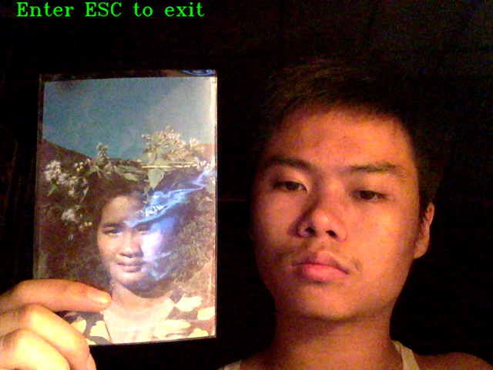
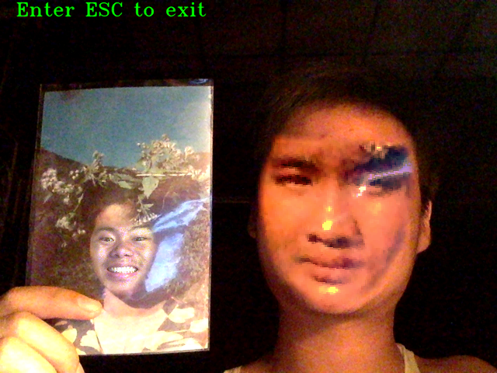
Feature 2: Adding Mask
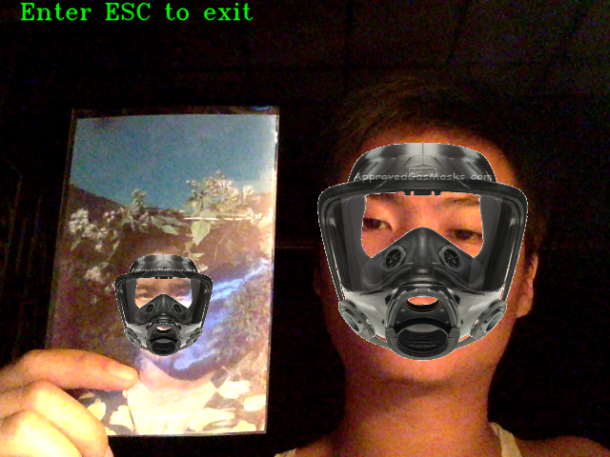
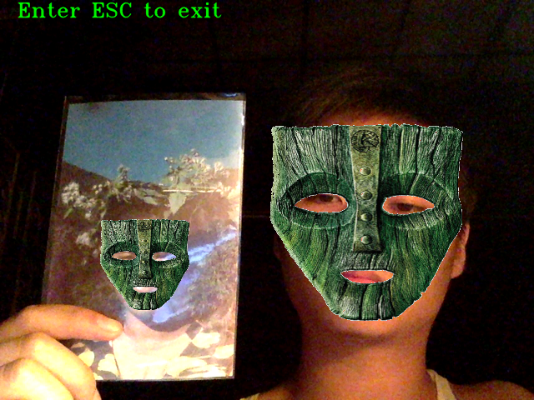
Feature 3: Colour Mapping
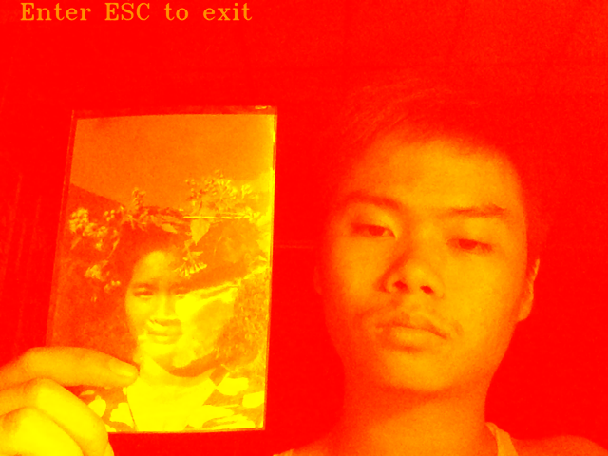
Autumn Tone
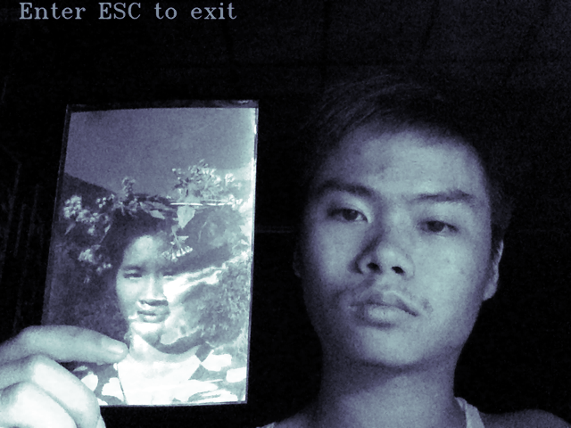
Bone Tone

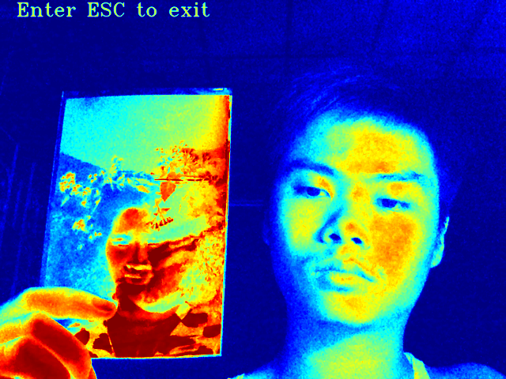
HSV Tone
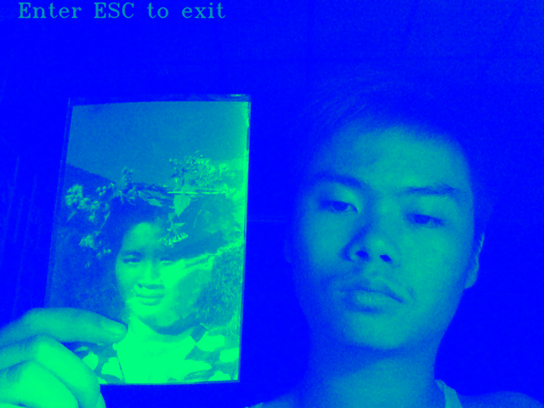
Winter Tone

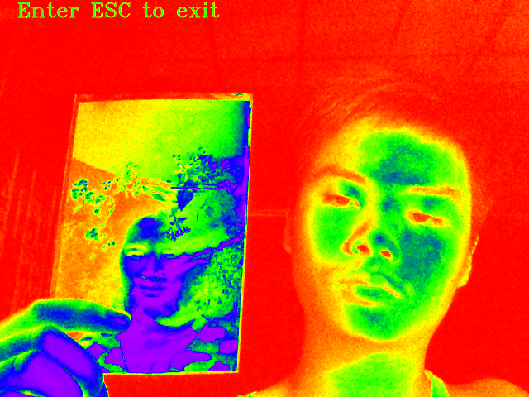
Rainbow Tone
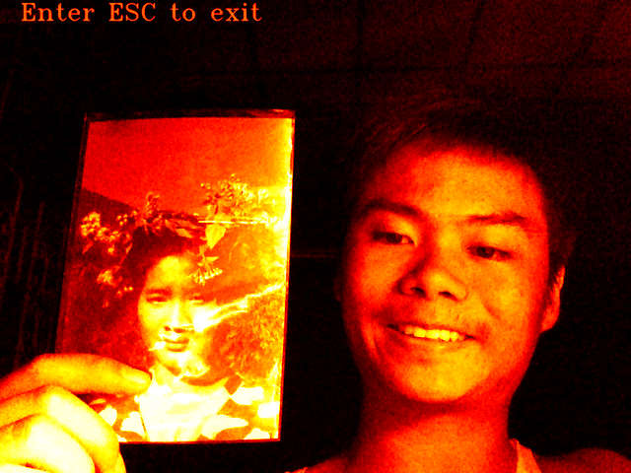
Hot Tone

